LOAN APPROVAL PREDICTION
Machine Learning Model Comparison & GitHub Project Report

Prepared from the supplied Python notebook/code

1. Executive Summary
This project develops a loan approval classification workflow using applicant-level information. The pipeline inspects the dataset, identifies missing values, imputes selected missing fields, converts categorical values into numeric representations, and compares five machine-learning classifiers using 5-fold cross-validation. The objective is to identify which of the evaluated models provides the strongest cross-validated classification accuracy on the supplied dataset.
The project is structured for reproducibility and GitHub publication. Model accuracy figures are intentionally not included in this report until the notebook is executed against the actual loan_prediction.csv dataset; this avoids presenting fabricated results.

2. Project Objectives
- Understand the structure and quality of the loan dataset.
- Handle missing values using simple statistical imputation.
- Transform categorical variables into machine-readable numeric values.
- Evaluate five classification algorithms with 5-fold cross-validation.
- Visualize model performance for comparison.
- Package the project in a GitHub-ready structure.

3. Machine Learning Models
Model | Purpose | Evaluation
Gradient Boosting | Sequential ensemble classifier | 5-fold CV accuracy
Random Forest | Tree-based ensemble classifier | 5-fold CV accuracy
Decision Tree | Single tree classifier | 5-fold CV accuracy
K-Nearest Neighbor | Distance-based classifier | 5-fold CV accuracy
Linear SVM | Linear margin-based classifier | 5-fold CV accuracy

4. Data Preparation
Categorical missing values are filled with the most frequent category. LoanAmount is filled using its mean. Selected categorical variables are mapped to integer values. Loan_ID is excluded from the predictors because it is an identifier rather than a predictive feature.

5. Cross-Validation & Results
The notebook uses 5-fold cross-validation and reports mean classification accuracy for each model. Execute the notebook to generate the definitive values.
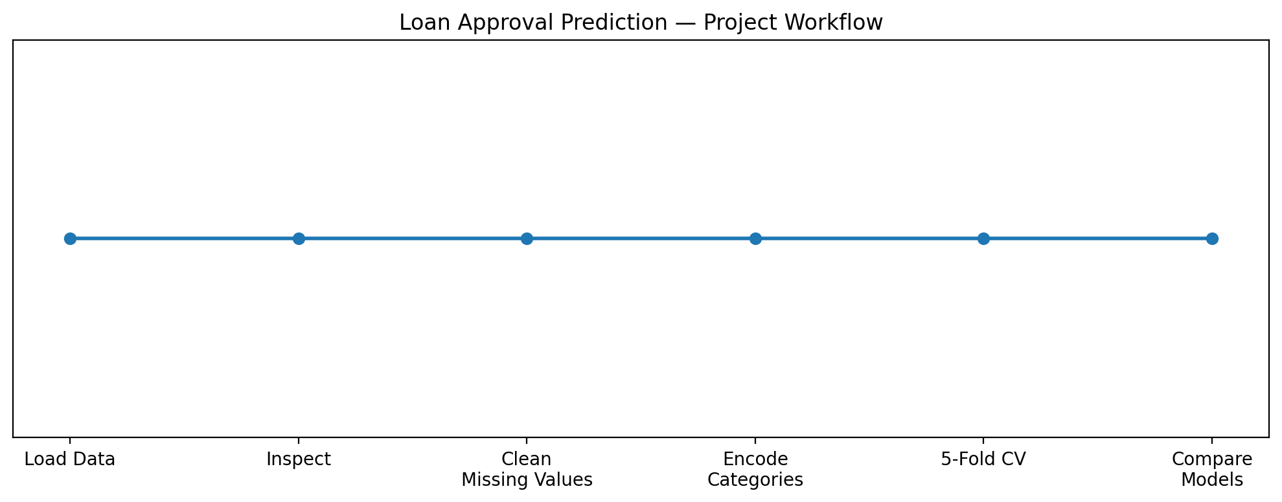
Figure 1. Project workflow.

Model Comparison Chart
The model-comparison chart is generated automatically by the notebook after execution. The actual chart is not embedded here because the dataset and executed model outputs were not supplied in this conversation.

6. Notebook / GitHub Links
Local project files included in the package:
- loan_approval_prediction.ipynb
- loan_approval_prediction.py
- README.md
- requirements.txt
GitHub notebook URL template: https://github.com/<YOUR_USERNAME>/loan-approval-prediction/blob/main/loan_approval_prediction.ipynb
Replace <YOUR_USERNAME> with the GitHub account used to publish the repository.

7. Notebook Screenshot
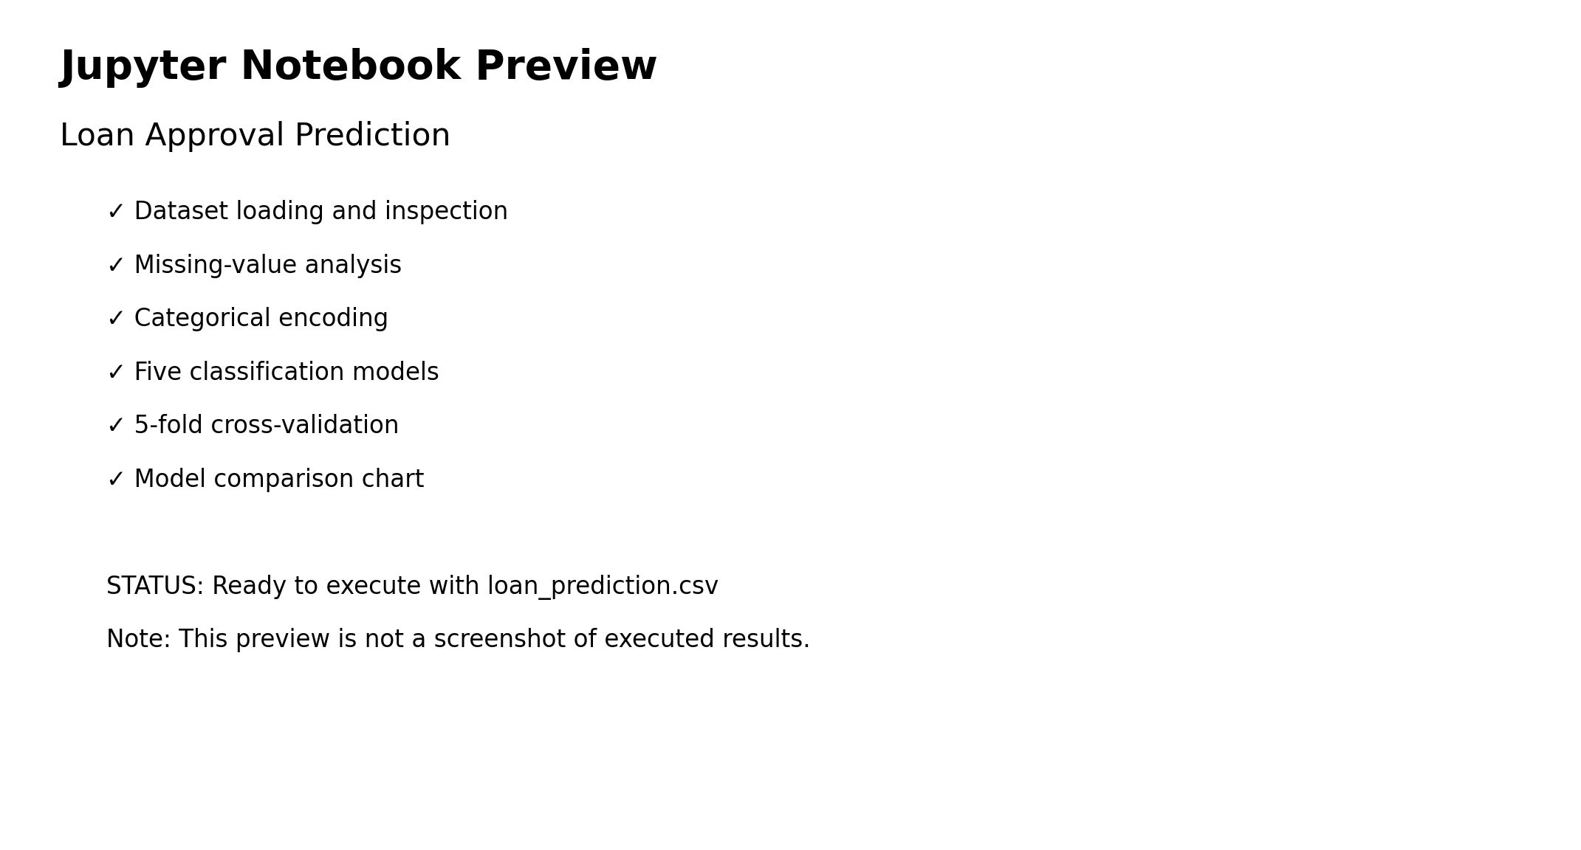
Figure 2. Notebook/project preview. This is a generated preview, not an executed-results screenshot.
For the final portfolio version, replace this preview with a screenshot of the executed Jupyter notebook showing the dataset output and model-comparison chart.

8. GitHub Publishing Instructions
- Create a new GitHub repository named loan-approval-prediction.
- Place the notebook, Python script, README, requirements file, report, and permitted dataset in the repository.
- Install dependencies using pip install -r requirements.txt.
- Run all notebook cells and save the generated model_comparison.png.
- Commit the project with a clear message such as: Add loan approval prediction project.
- Push the main branch to GitHub.

9. Recommended Improvements
- Use a scikit-learn Pipeline and ColumnTransformer for cleaner preprocessing.
- Scale features before KNN and Linear SVM.
- Use one-hot encoding for nominal variables such as Property_Area.
- Report precision, recall, F1-score, confusion matrix, and ROC-AUC in addition to accuracy.
- Use stratified cross-validation for classification when class balance is a concern.
- Tune model hyperparameters rather than relying only on default settings.
- Assess fairness and error costs before using a model for real lending decisions.

10. Conclusion
The project provides a clear baseline for comparing classification algorithms for loan approval prediction. It is suitable as a learning or portfolio project once the notebook has been executed, the real metrics and chart have been captured, and the GitHub repository has been populated with the final artifacts.

